OOREDOO MYANMAR
Minutes for Apr’24 Review (Thursday, May 23rd, 2024)
Review Waived

Attendees:
OG: Ahmad Al Neama, Vipul Sharma, Anandi Agnihotri, Tomas Ramirez, Htar Thant Zin, Sean Borejszo, Helene Le Caignec, Online: Alok Verma, Emre Cicek, Mark Brownscombe, Zin Mar Aung
OML: Christopher Peirce (CEO), Ramanathan Sivakumar (CFO), Jeremy Ratadhi (CHRO), Jose Sierra (CTIO), Carlos Eduardo Quiroga Tarradelles (CCO), Joydeep Sarkar (Head of B2B and FTTX), Nalin Jain (Head of Marketing), Shouvik Ray (Head of S&D), Aye Myat Thandar Oo, Nitin Anand
Apologies: Aziz Ahmad AlUthman Fakroo, Abdullah Al Zaman, Fatima Al Kuwari, Saim Yaksan, Rene Werner, Timos Tsokanis, Sh. Nasser Al Thani, Eyas Asaf, Hilal Al Khulaifi, Najib Khan

 | Minutes | Action
1. | Opening Message:  Meeting was waived as physical review is not required and small points can be dealt with offline.  Q&A has been sent and below are OML’s answers
2. | Q&A  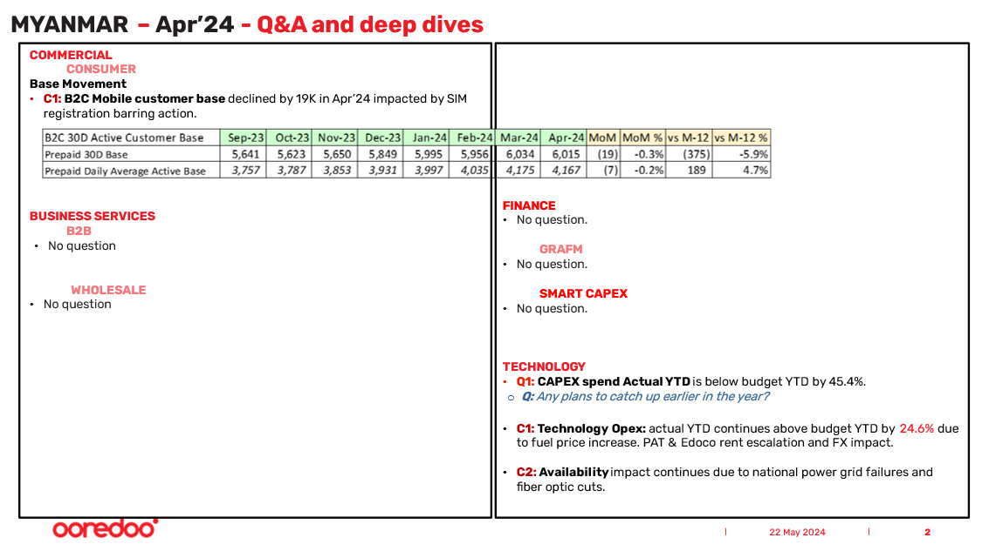  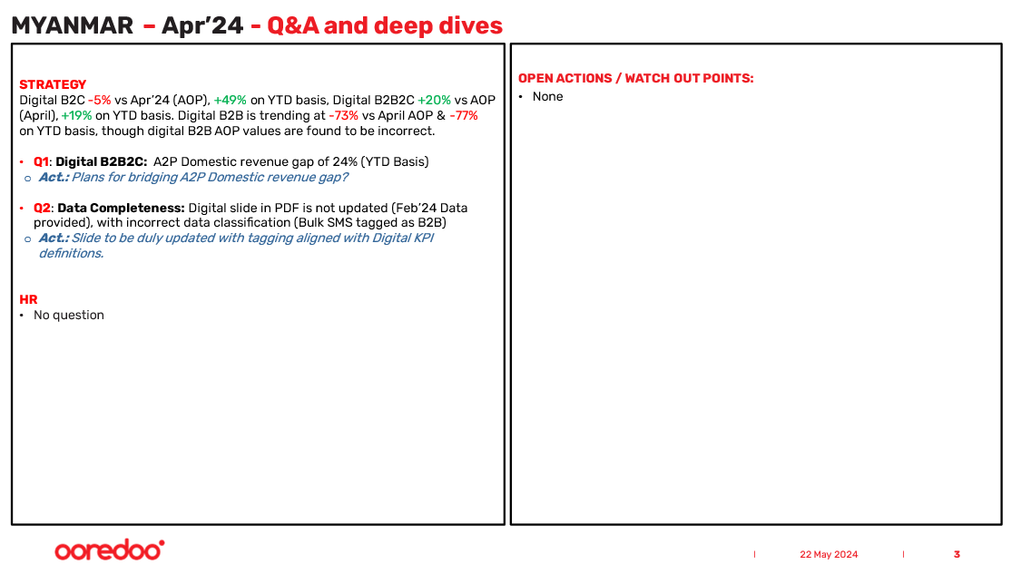  COMMERCIAL  CONSUMER  Base Movement  - C1: B2C Mobile customer base declined by 19K in Apr’24 impacted by SIM registration barring action.  FINANCE  - No question.  GRAFM  - No question.  SMART CAPEX  - No question.  TECHNOLOGY  - Q1: CAPEX spend Actual YTD is below budget YTD by 45.4%.  - Q: Any plans to catch up earlier in the year?  OML: “Behind the budget due to timing difference of some projects.”  - C1: Technology Opex: actual YTD continues above budget YTD by 24.6% due to fuel price increase. PAT & Edoco rent escalation and FX impact.  - C2: Availability impact continues due to national power grid failures and fiber optic cuts.  BUSINESS SERVICES  B2B  - No question  WHOLESALE  - No question  STRATEGY  Digital B2C -5% vs Apr’24 (AOP), +49% on YTD basis, Digital B2B2C +20% vs AOP (April), +19% on YTD basis. Digital B2B is trending at -73% vs April AOP & -77% on YTD basis, though digital B2B AOP values are found to be incorrect.  - Q1: Digital B2B2C: A2P Domestic revenue gap of 24% (YTD Basis)  - Act.: Plans for bridging A2P Domestic revenue gap?  OML: “Bulk SM reversal in Feb due to wrong billing of last year adjusted in Feb, Current run rate revenue 80Mn. Shortfall will be made up by Q3”  - Q2: Data Completeness: Digital slide in PDF is not updated (Feb’24 Data provided), with incorrect data classification (Bulk SMS tagged as B2B)  - Act.: Slide to be duly updated with tagging aligned with Digital KPI definitions.  HR  - No question  OPEN ACTIONS / WATCH OUT POINTS:  - None
3. | Closing Words  - .
4. | Open Actions – General reminder that open actions as shared by the OG Performance Team should be addressed and followed up by the dates requested.

